Project Planning Phase
India's Agricultural Crop Production Analysis
Project Title | India's Agricultural Crop Production Analysis
Domain | Agriculture / Data Analytics & Business Intelligence
Tool | Tableau Desktop / Tableau Public
Dataset | Historical Indian Crop Production Data, 1997–2021
Prepared By | Divya Kauluri (Team Project — completed individually; the team lead and other assigned members did not contribute to the work)
Mentor | [Not yet assigned / add name]
GitHub Repository | https://github.com/divyakauluri-spec/India-s-agricultural-crop-production-analysis
Tableau Public Link | https://public.tableau.com/app/profile/divya.kauluri/viz/IndiaAgricultureanalysisproject
Date | 02/07/2026

4.1 Product Backlog & Sprint Schedule
As an individual contributor, I am assigned to every task below across all 3 sprints.
Epic # | Epic Name | User Story / Task | Story Points | Priority | Assigned To | Sprint
1 | Data Collection | Download and verify official dataset (345K rows, 1997–2021) | 2 | High | Divya Kauluri | Sprint 1
1 | Data Collection | Confirm dataset columns: State, District, Crop, Year, Season, Area, Production | 1 | High | Divya Kauluri | Sprint 1
2 | Data Preparation | Clean dataset using Python Pandas (rename, strip whitespace, extract year, add Yield) | 3 | High | Divya Kauluri | Sprint 1
2 | Data Preparation | Connect cleaned CSV to Tableau; set State Name geographic role | 2 | High | Divya Kauluri | Sprint 1
3 | Data Visualization | Build State-wise Production filled map with Season + Year filters | 3 | High | Divya Kauluri | Sprint 1
3 | Data Visualization | Build Year-wise Production Trend line chart (1997–2021) | 2 | High | Divya Kauluri | Sprint 1
3 | Data Visualization | Build Top 10 Crops by Production horizontal bar chart | 2 | High | Divya Kauluri | Sprint 2
3 | Data Visualization | Build Season-wise Production bar chart | 2 | Medium | Divya Kauluri | Sprint 2
3 | Data Visualization | Build Crop-wise Treemap (exclude Coconut outlier) | 3 | Medium | Divya Kauluri | Sprint 2
4 | Dashboard | Assemble Farmer Dashboard (Season-wise + Top 10 Crops) | 3 | High | Divya Kauluri | Sprint 2
4 | Dashboard | Assemble Policy Analyst Dashboard (Map + Year Trend + filters) | 3 | High | Divya Kauluri | Sprint 2
4 | Dashboard | Assemble Investor Dashboard (Top 10 Crops + Treemap) | 2 | Medium | Divya Kauluri | Sprint 2
5 | Story | Build Tableau Story with 3 story points (one per persona) and captions | 3 | Medium | Divya Kauluri | Sprint 3
6 | Performance Testing | Test all filters for responsiveness; document load time and data volume | 2 | Medium | Divya Kauluri | Sprint 3
7 | Web Integration | Publish workbook to Tableau Public; verify URL access | 2 | High | Divya Kauluri | Sprint 3
8 | Documentation | Complete all GitHub repository deliverables (docs, report, screenshots) | 5 | High | Divya Kauluri | Sprint 3
8 | Documentation | Record demonstration video (60–90 seconds) | 3 | High | Divya Kauluri | Sprint 3

Velocity: Sprint 1 = 13 points | Sprint 2 = 16 points | Sprint 3 = 12 points | Total = 41 story points

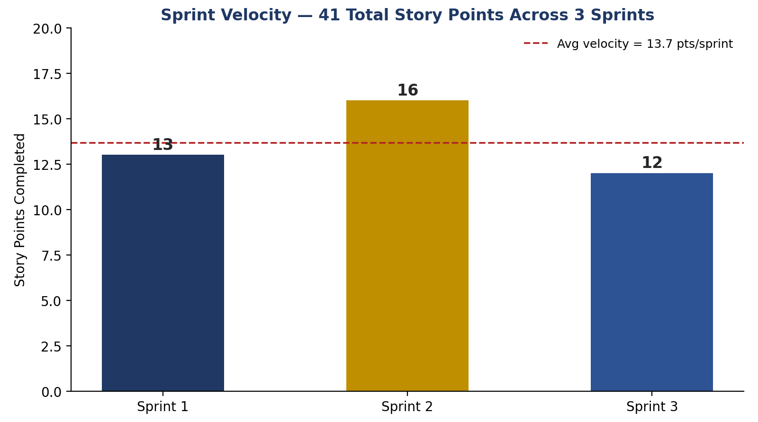
Figure 4.1 — Sprint Velocity (Story Points Completed per Sprint)
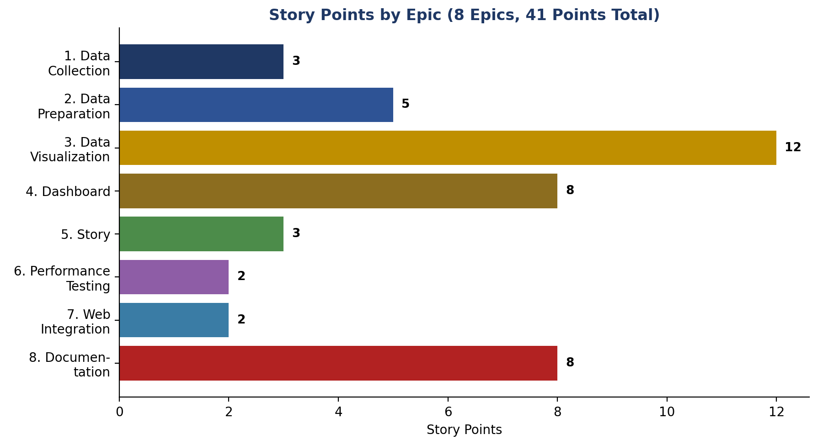

Reading the Velocity Trend

Sprint 2 carried the heaviest load (16 points) because it covered both dashboard assembly and the Tableau Story, the two most integration-heavy deliverables. Sprint 3's lighter total (12 points) reflects testing and documentation work, which is comparatively less effort-intensive than original chart and dashboard construction — a normal taper for a single-contributor schedule with no parallel workstreams to offset the reduced headcount.

